**Advanced Internet Technologies – Demo 1**

1. Open Visual Studio 2015 via the *Start->Programs* menu option.
2. Create a New Project (*File->New->Project*). Choose *Visual C#/Windows/Console Application* as the template type. Name the project *HelloWorld.* Createthe project on either your H: drive or the C: drive.

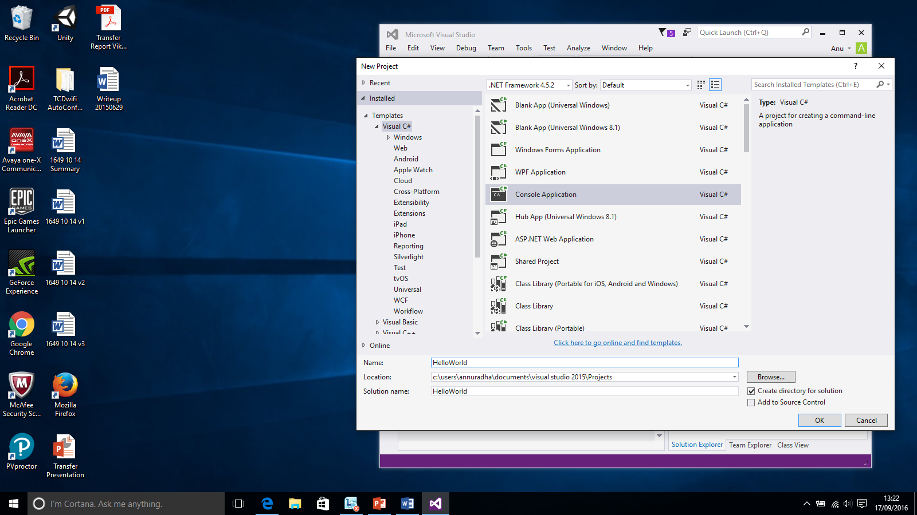

1. Program.cs will open in the Code Editor. If not, open the shortcut menu for Program.cs in Solution Explorer, and then choose View Code.

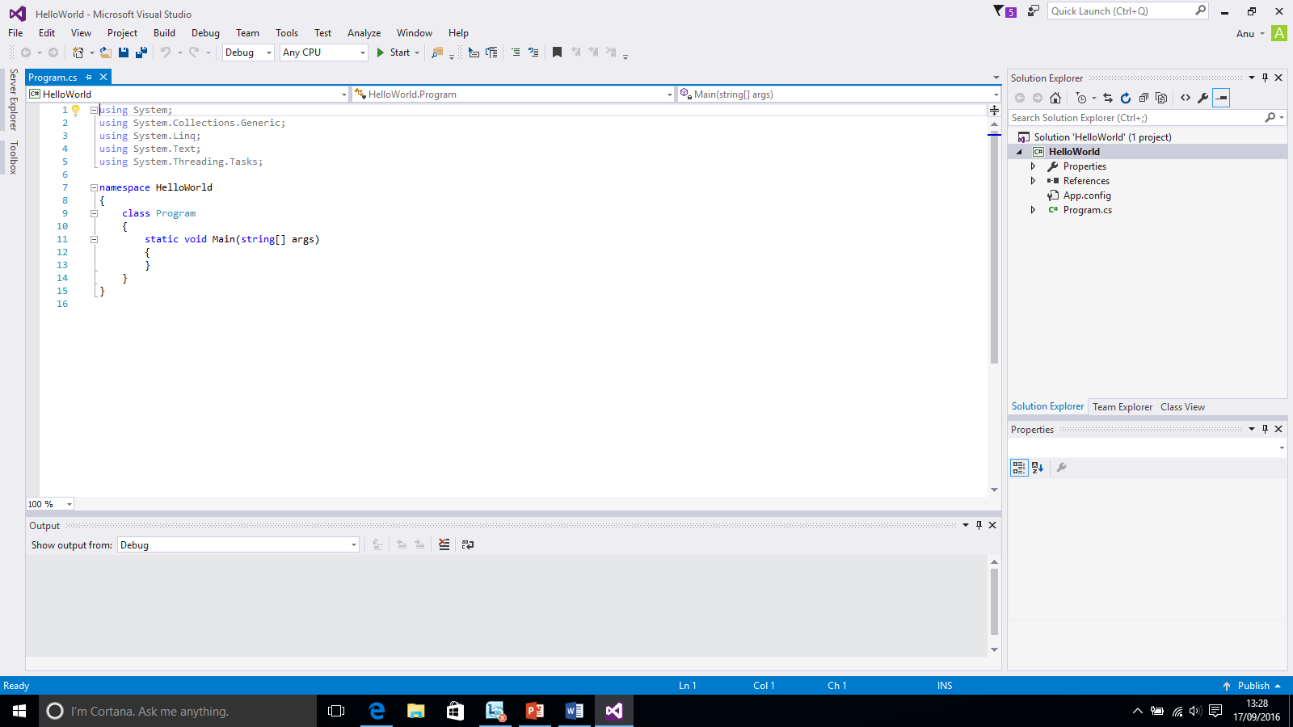

1. Add the contents to Program.cs with the code in the screenshot and click Start on the toolbar.

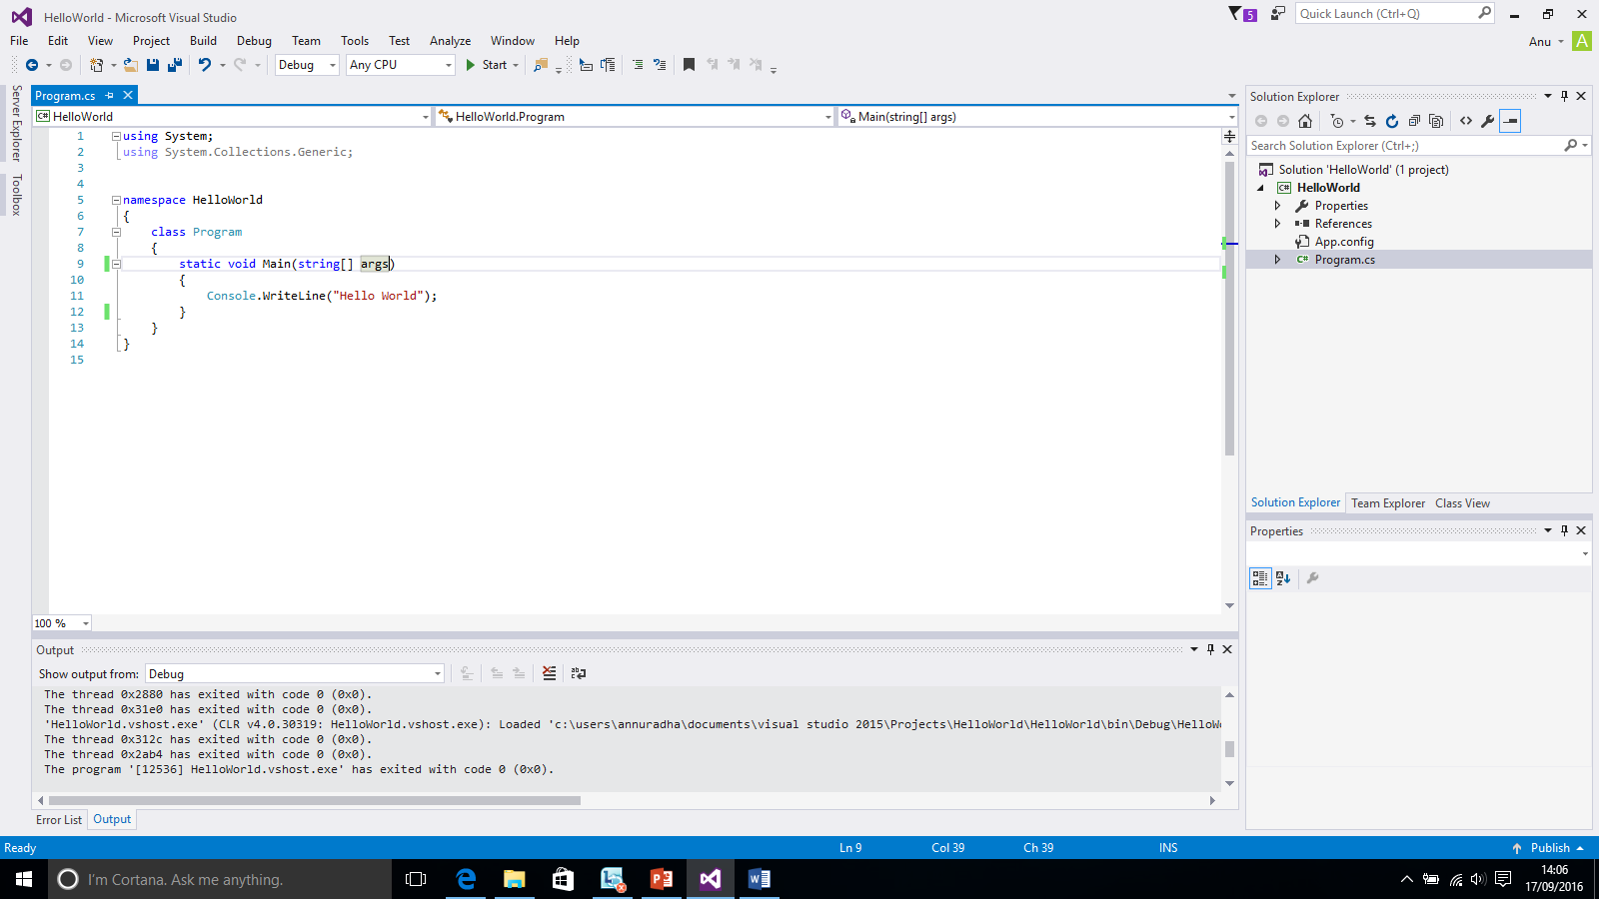

1. The console appears and disappears quickly.
2. Now add the following lines as shown in the screenshot to the code.

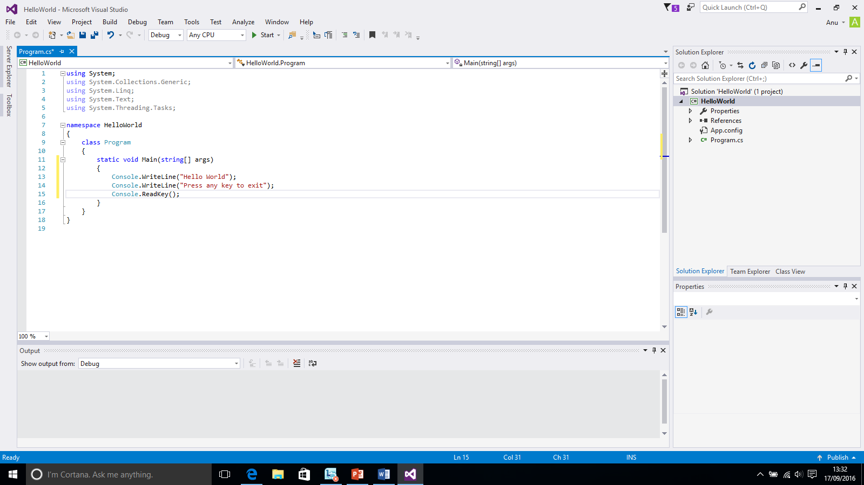

1. Run the project.

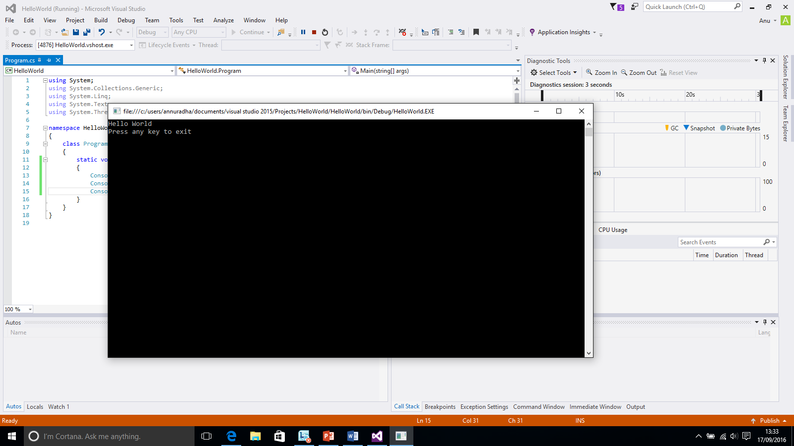

1. Now press any key to close the console window.
2. The *Solution Explorer* (by default on the right-hand-side of the IDE) will give you a view of all files etc. associated with the project.